FMX Mobile Application Development
Lab Exercise 02.02: Creating users and setting up privileges for each

To create a new user, follow these steps:
- Login as user SYSDBA.
- Use Server > User Security ...
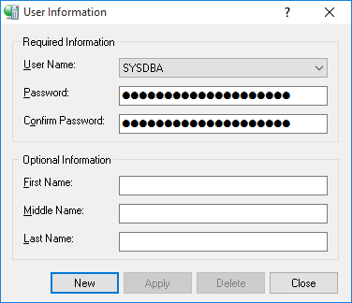
- Select New.
- Fill out the required fields:
  - User Name: MGMT.
  - Password: manager.
  - Confirm Password: manager.
- Select Apply.
- Repeat step 5 for a user called staff with the password: staff

